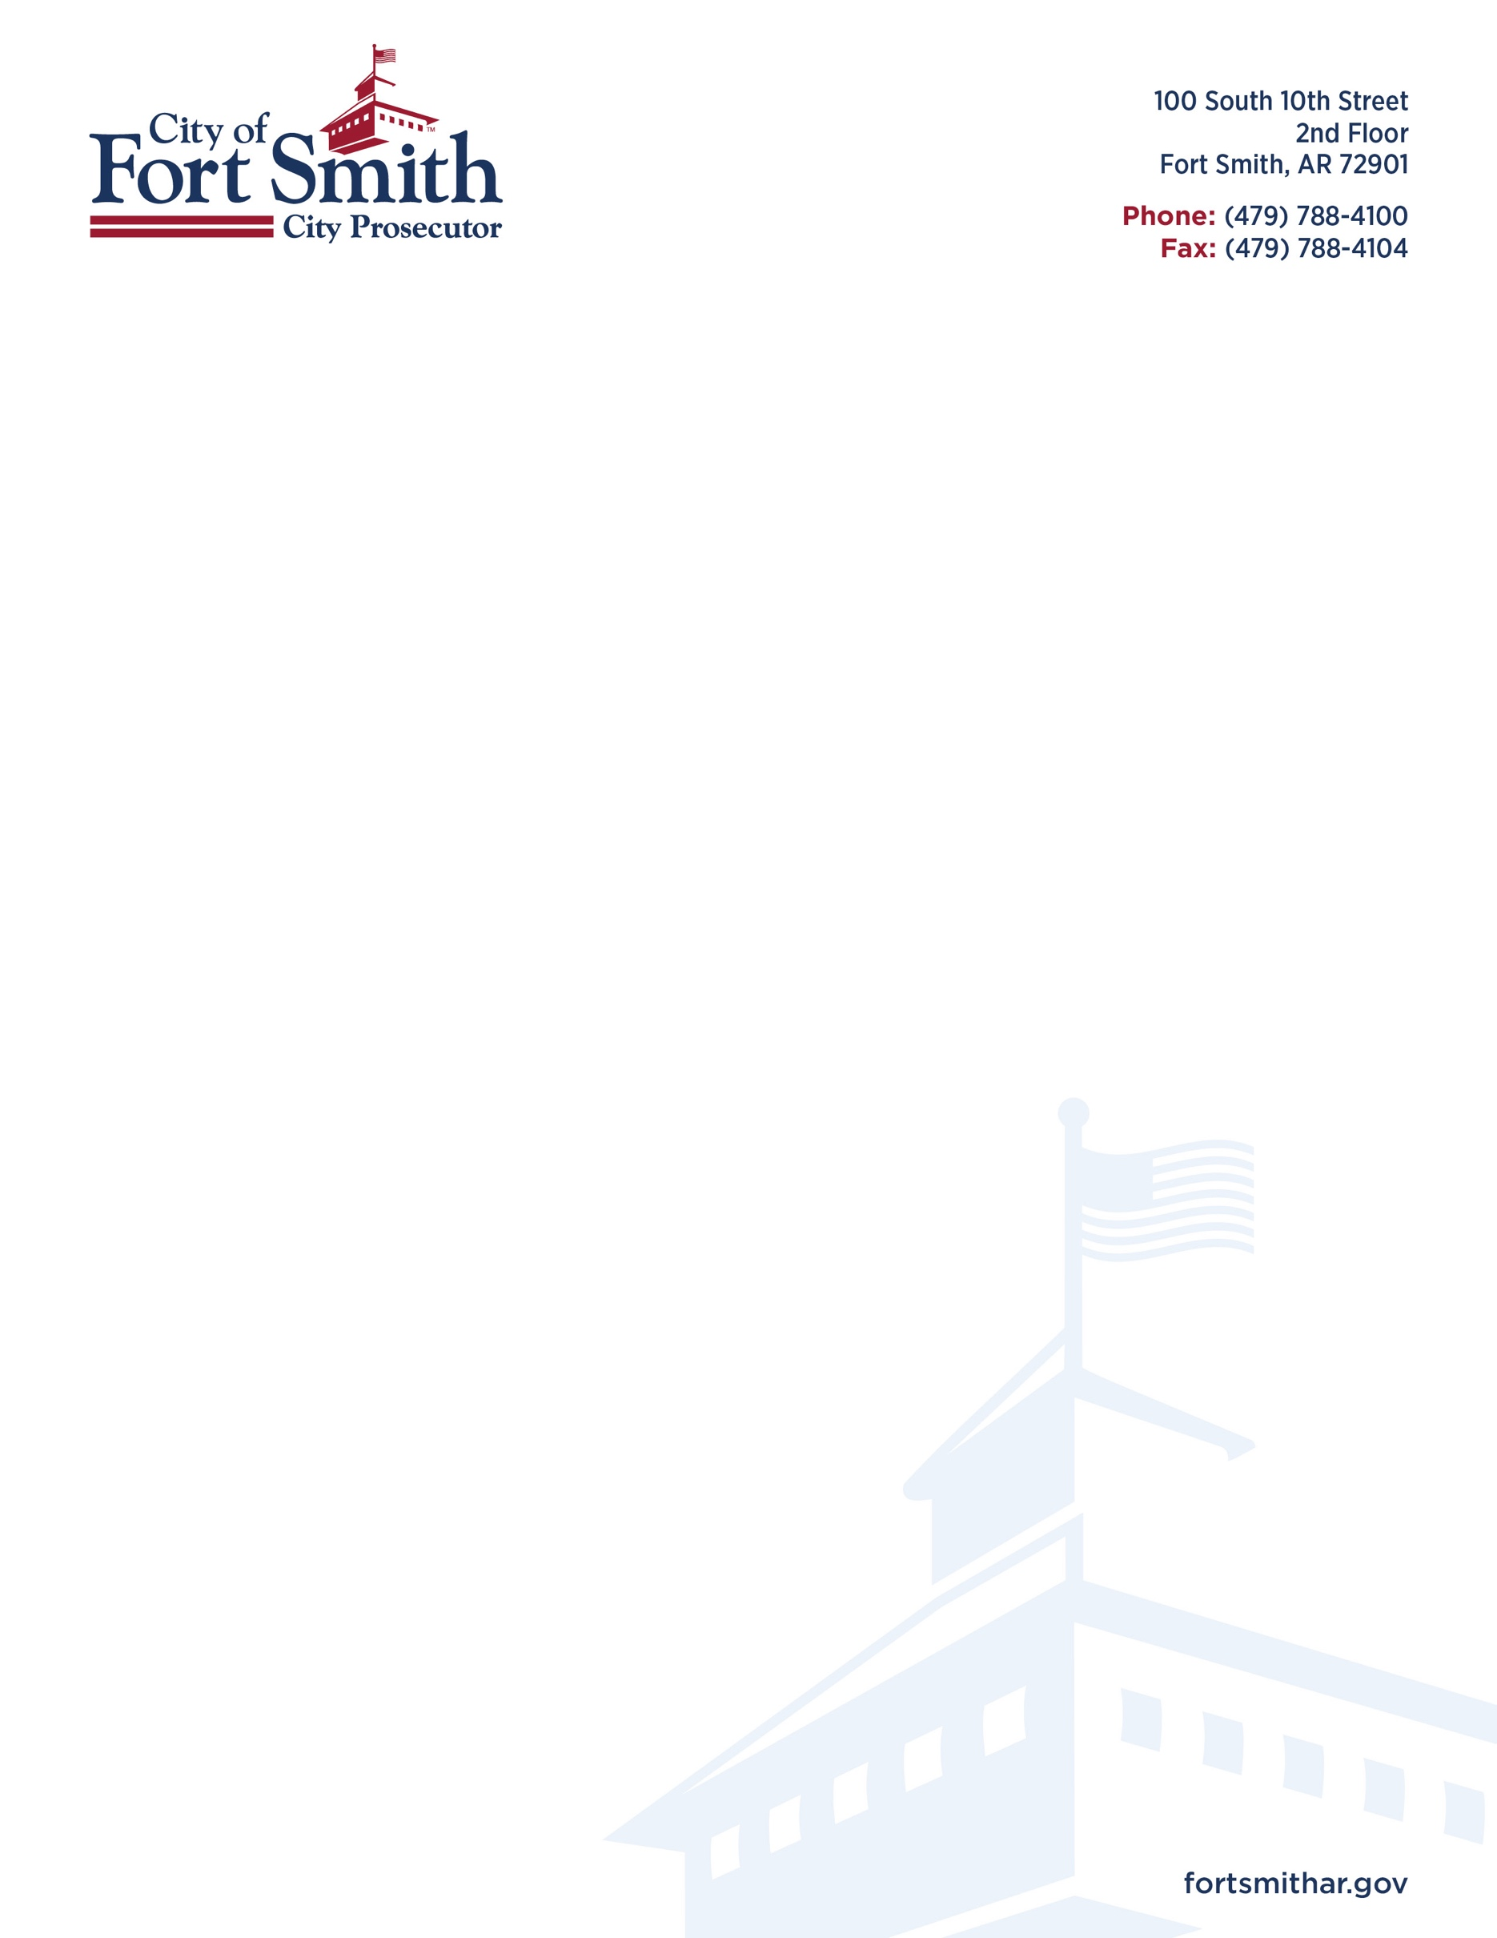

**MISDEMEANOR CASES INVOLVING SOCIAL MEDIA**

In order to attempt to successfully prosecute a case that is strictly based on threats or harassment through social media, there are several investigative requirements that must be completed. Local law enforcement generally does not assign investigators to misdemeanor cases. Our office understands that local law enforcement must prioritize their limited resources in determining which cases to investigate.

First, the City would need to send a Letter of Preservation to the Social Media Provider, and then in order to access the social media account user information, a search warrant would be required. The Social Media Provider is usually an out-of-state entity, and in some instances, is located overseas. Second, in order to attempt to determine the location where the social media account was accessed, a subpoena must be issued to the Internet Service Provider in order to determine the Internet Protocol (IP) Address of the device used to access the social media account. Both social media providers and internet service providers bill our office for actions that they perform.

Third, in order to seize the device used to access the social media account, a second search warrant is required to search the location identified by the IP address where the device is believed to be located. Upon the location of the device, another search warrant would also be required to access the potential evidence which is stored on the device.

Finally, in order to present any of the evidence that is obtained through the above-described investigation, the custodian of records for the social media provider and the internet service provider would be required to testify in the case. In order to secure their attendance, an Interstate Subpoena would be required, and would involve the participation of the Prosecuting Attorney’s Office in the foreign jurisdiction. In the event that the custodians of records are successfully served with a subpoena, the social media providers and internet service providers usually require that the travel expenses of the witness be paid for by the party that has issued the subpoena in order for them to agree to testify.

Once all of these time-consuming and extremely costly procedures have been completed, there is still an issue of proving beyond a reasonable doubt who actually committed the offense. Unless the defendant has given a confession, proving beyond a reasonable doubt who was in control of the social media account at the time that the offense was committed is almost always impossible – we still have to prove who was behind the keyboard. Therefore, even if the City of Fort Smith Prosecuting Attorney’s Office goes through the extensive effort of obtaining the evidence and securing the necessary witnesses, the probability of a successful prosecution is extremely unlikely. For all of these reasons, it is the policy of the City of Fort Smith Prosecuting Attorney’s Office not to initiate prosecution in cases where an alleged misdemeanor offense has been committed over social media.